**LI: to understand the benefits of waste management**

Humans produce MILLIONS of tonnes of rubbish every year.

Up to 60% of our rubbish can be recycled. Any rubbish not recycled ends up at landfill sites and is harmful for our environment.

**FACTS:**

* 1 recycled tin can would save enough energy to power a television for 3 hours.
* 1 recycled glass bottle would save enough energy to power a computer for 5000 hours.

**Task:**

Cut out all of the objects on the page attached. Then see if you can figure out which recycling category they go into and glue them in the correct columns below.

|  |  |  |  |  |
| --- | --- | --- | --- | --- |
| **METAL** | **PAPER / CARDBOARD** | **GLASS** | **PLASTIC** | **FOOD COMPOST** |
|  |  |  |  |  |

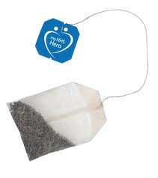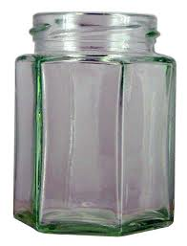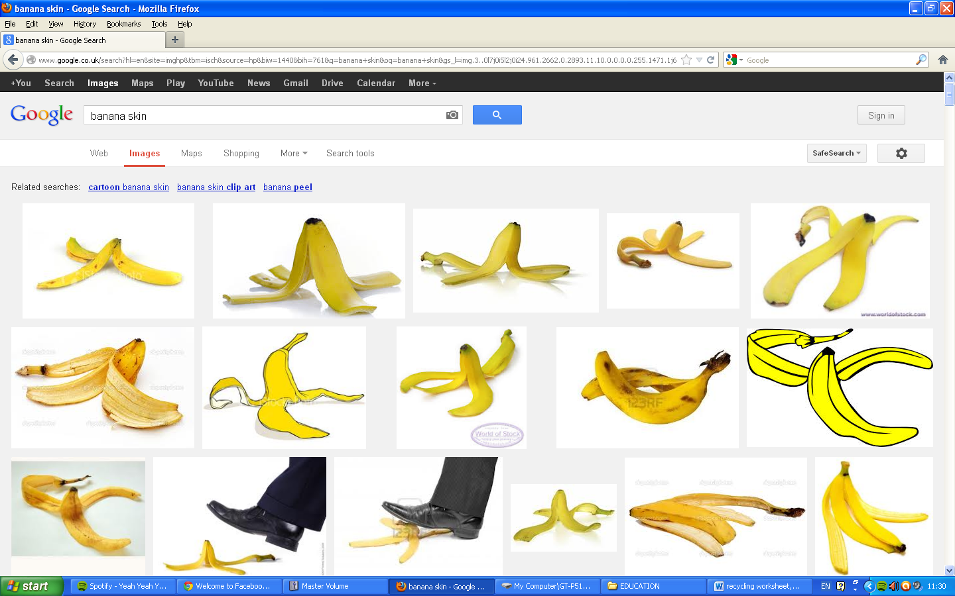

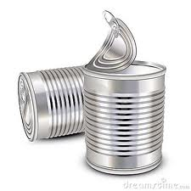

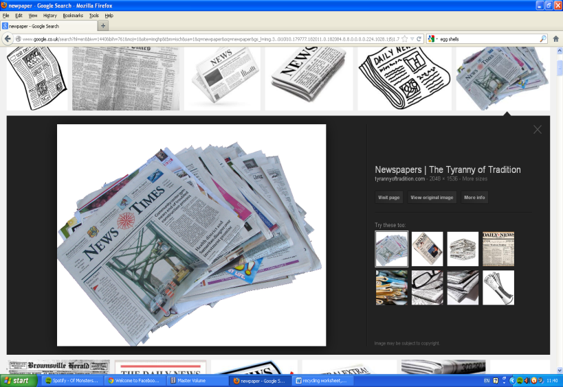

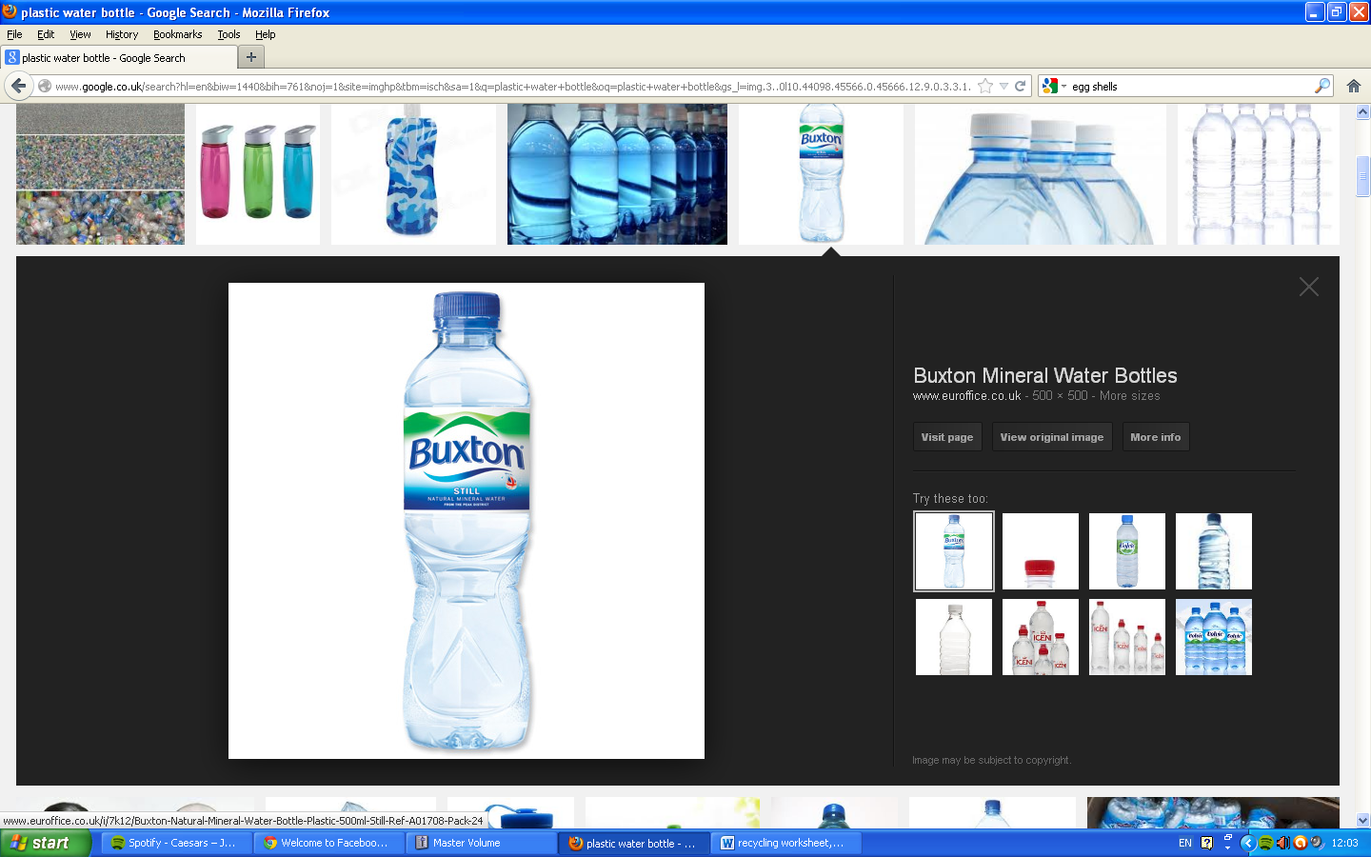

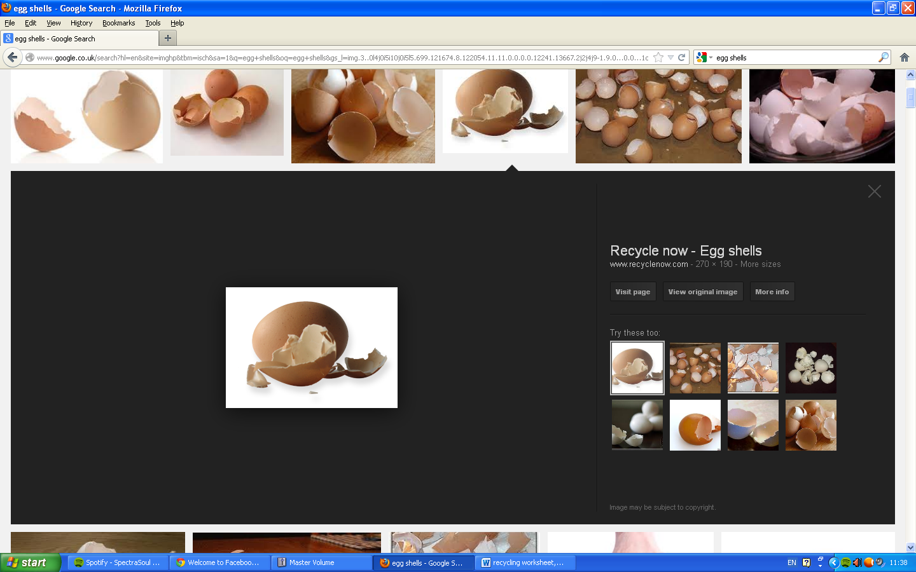

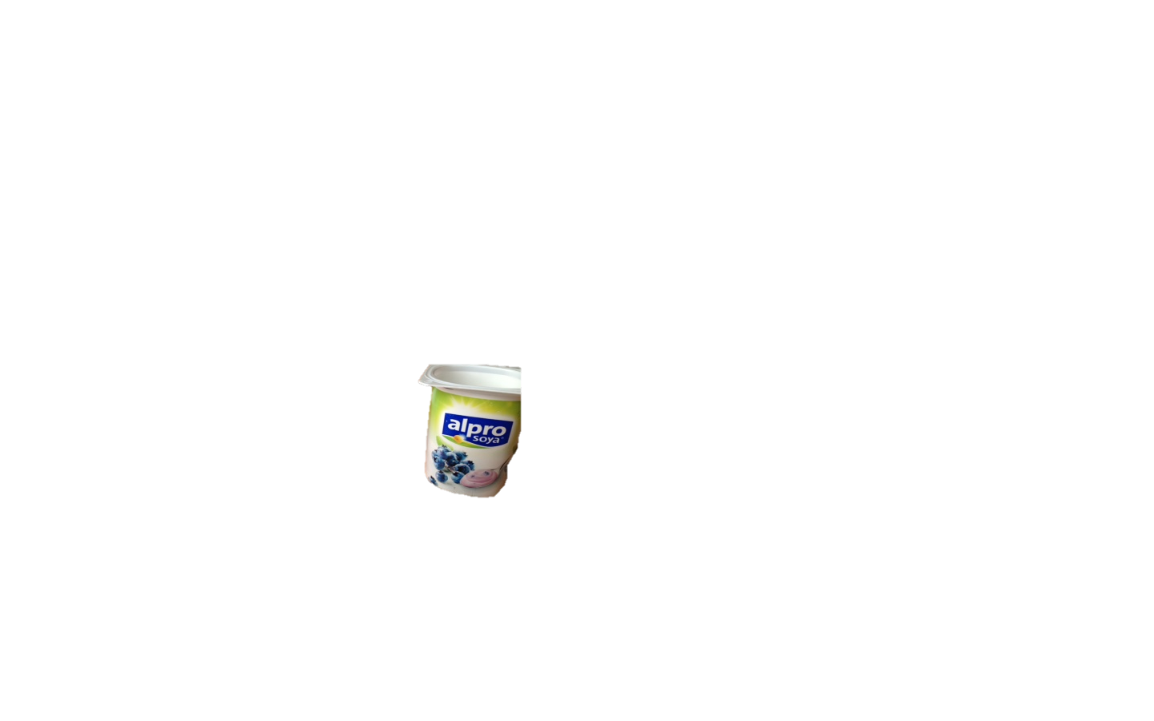

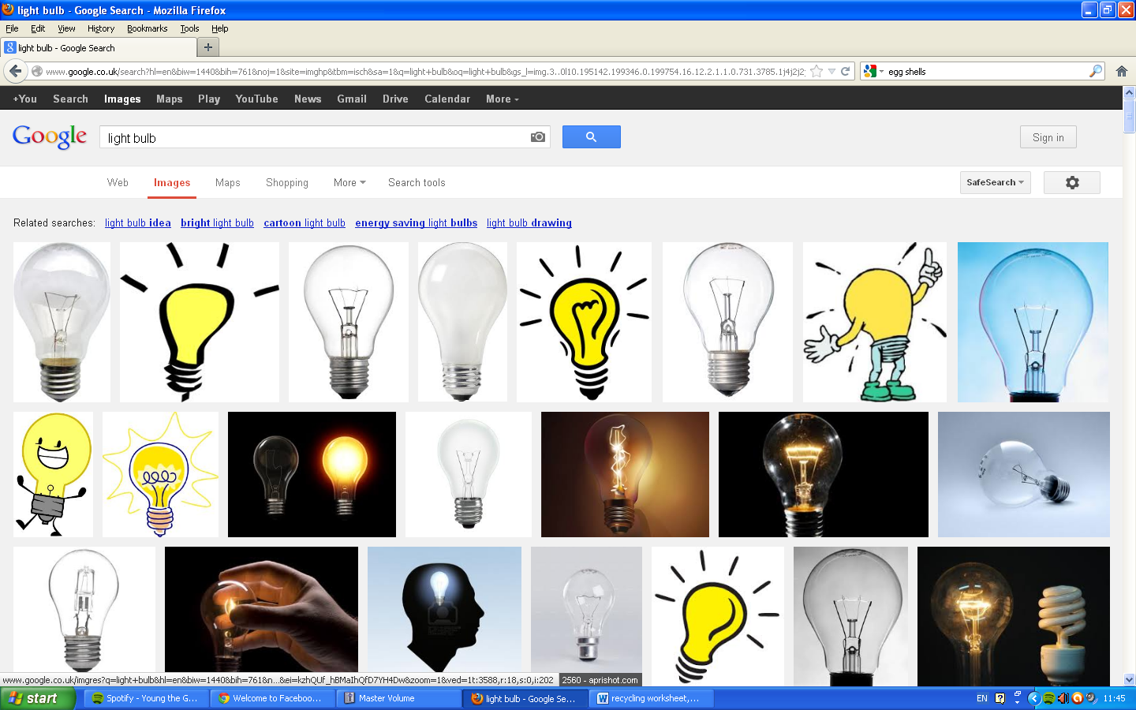

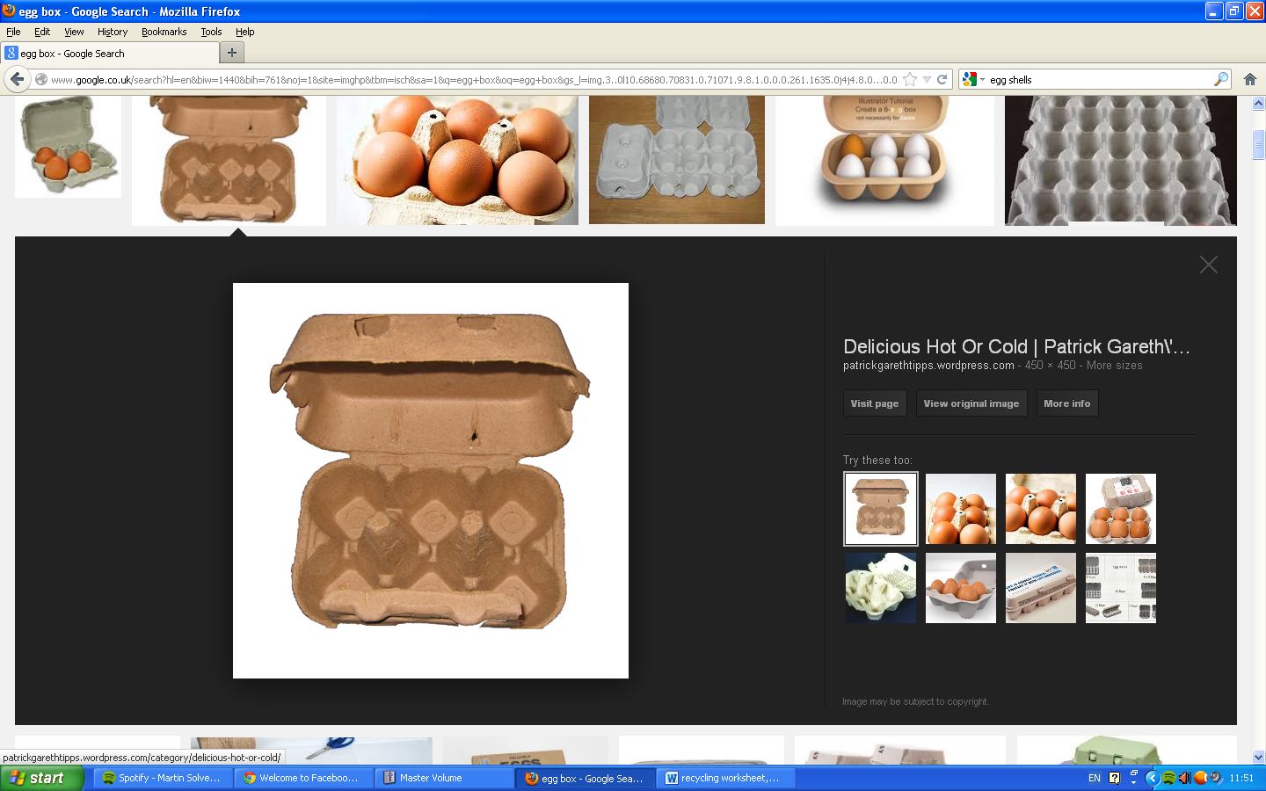

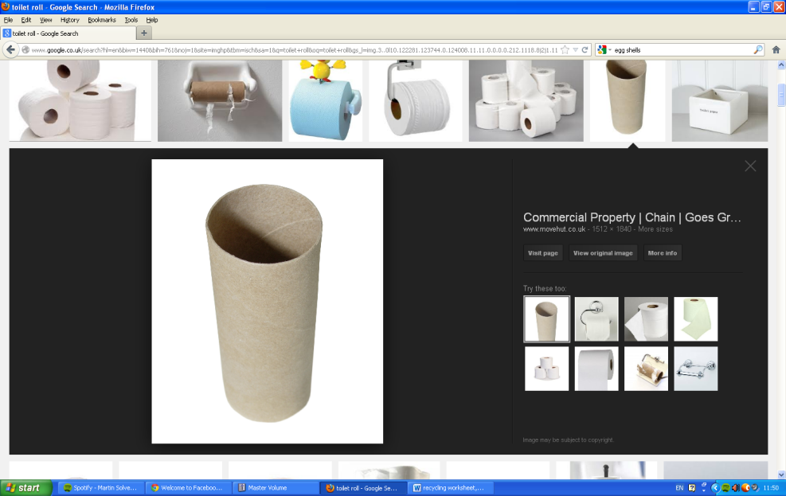

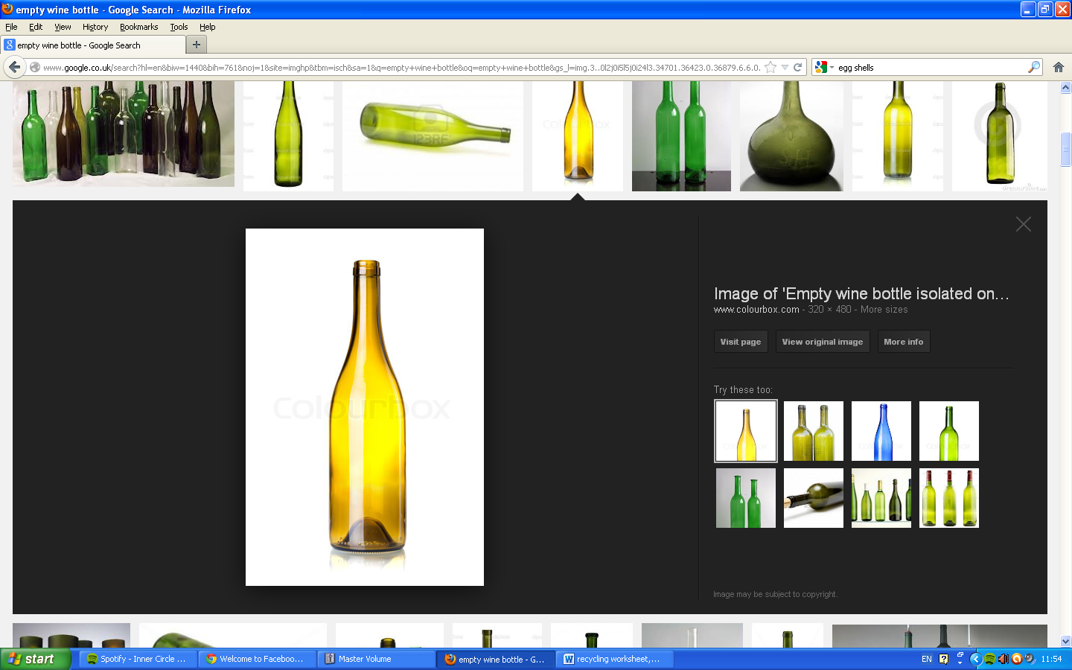

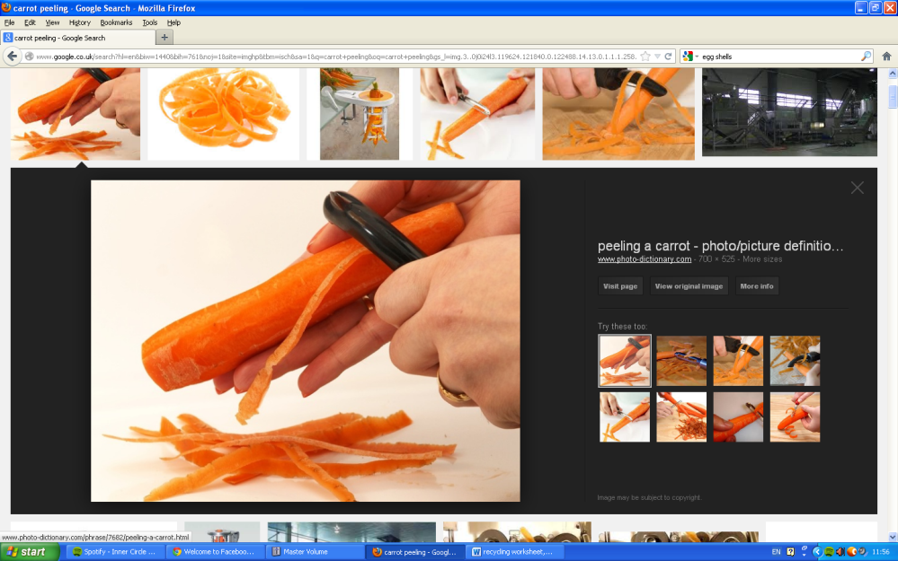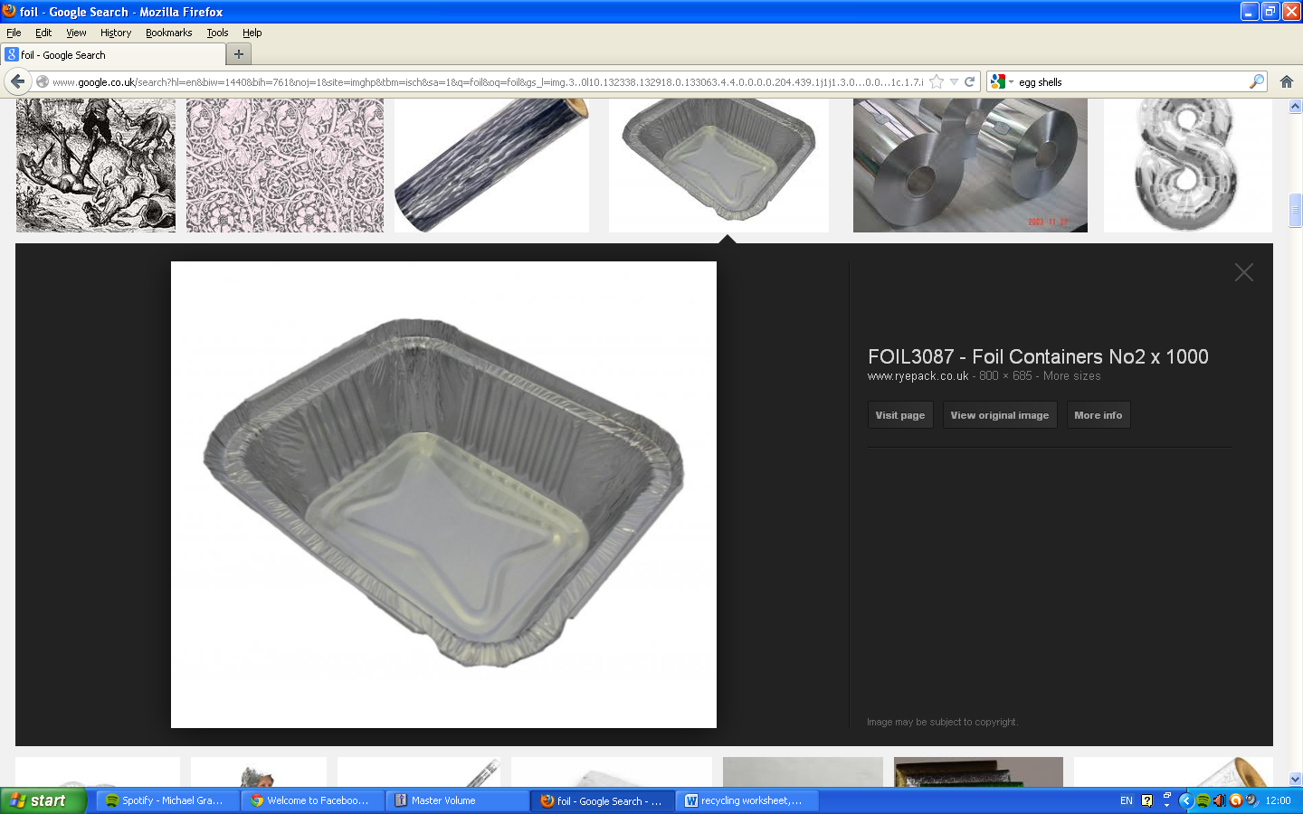

Raising Awareness & Inspiring Action

Raising Awareness & Inspiring Action