Analysing a Newspaper Report
Read this newspaper report and answer the questions.
___________________________________________________

Dirty Diving

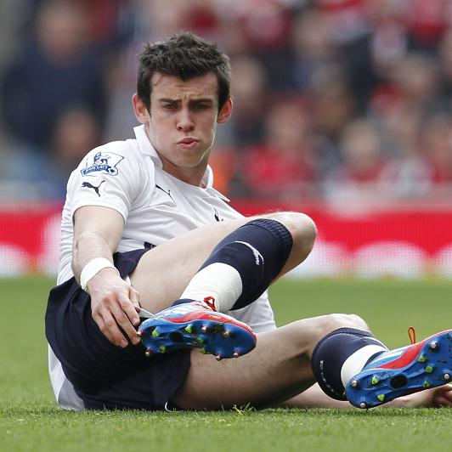
Spurs winger has no option but to take evasive action from tough tackles after coming under fire again

By Tom Collomose

Gareth Bale today hit back at accusations that he dives by claiming he is just trying to protect himself from serious injury.
The Tottenham winger has been criticised this season for “going to ground” too easily and Stevenage manager Gary Smith was unhappy that Bale was granted a penalty when challenged by Mark Roberts last night.

‘I tend not to dive’, insists Bale

Doubts were also expressed about the
spot-kick awarded to Bale during the north London derby last month, yet the Welshman insists he has
Bale Tale Fail...rumours are wide of the mark

no option but to take evasive action from aggressive, dirty tackles: “I try not to get in the way of tackles and if people want to say I’m diving then they can but I’m trying to get out of the way and save myself, save my career if you like”, he said. “You’ve got people flying in at you.

“If you stand there, you’re going to get a whack. Sometimes it looks like you’re diving but if someone’s coming across you, you try to get out of the way. You can see why people say you’re diving but I’d rather dive – meaning get out of the way - than get hurt. I tend not to dive”.

Harry Redknapp has blasted claims that Gareth Bale is a diver – saying: He just gets kicked all the time!
Spurs manager Harry Redknapp defended his player recently saying, “I don’t think he dives”, but also suggested that Bale would need to accept that rough treatment will increase as his reputation grows. Redknapp used the examples of Lionel Messi and Cristiano Renaldo, probably the two most tightly-marked players in the game, to show Bale what he can expect as his career develops.
He believes Bale should regard it as a compliment if teams seek to stop him by illegal means and the 22-year old admitted he takes a degree of confidence from the way he is marked.

1.What are the purposes of this text? Explain your ideas.

2. How does the report try to attract the attention of the reader?

3. What is the effect of the headline, sub-heading and captions?

4.What impression is given of Gareth Bale in this report?

5. What language techniques can you identify? What are their effects?

