Handwriting practise
LI: to use cursive handwriting to form letters
Use the following ideas as guide to practise your handwriting. Use your common words or words from a story to practise.
Chalk  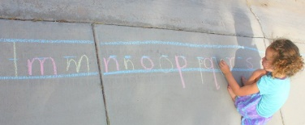  Write your words on a chalkboard or on a pavement. Use a different colour for vowels. | Paint  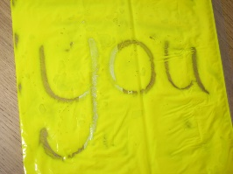  Ask an adult to put some paint in a small resealable bag. Use your fingers to practise your handwriting.
Pens  Instead of using a pencil, write down some words very carefully using pens. You can use a different colour for each word. | Pasta  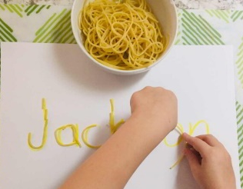  Ask an adult to cook some spaghetti. Once the spaghetti has cooled, form your cursive letters.
Playdough  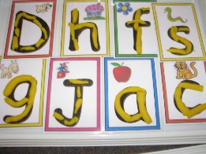  If you have playdough at home, make your cursive letters out of playdough. | Flour  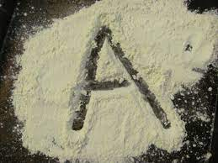  Ask an adult to spread some flour on a table. Write your words in your best cursive on the flour.

