Revision Sheet 2 – E***
- Write the number eighteen.

- Write the number that comes before 11.

- What is the difference between 9 and 2?

- What is the sum of 6 and 5?

- Tick the biggest number 21 25 17

- Tick the smallest number 15 25 18

- what is 2 + 3 + 3?

- Tick half way along this line.

- Put these flowers in bunches of 5, how many bunches do you have?

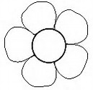

- The apple costs 1op. Colour the coins you would use to pay for the apple. 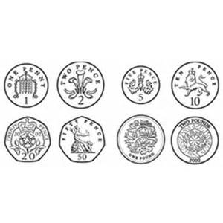
- What is 12 leave 7?

- There is 9 cats and 15 dogs. How many more dogs are there?

- The apple coats 10p and the banana cots 3p, how much more does the apple cost?

- Continue the sequence

5 7 9 11

20 18 16 14

