Revision Sheet 3 – E**
- Write the number after six.

- Write the number before nine.
- Tick the biggest number 4 5 7

- Tick the smallest number 2 6 9

- Add together 4 and 2.

- What is 5 take away 2?

- What is 4 less than 5?

- What is the total of 3 + 1 + 1

- Fill in the missing numbers

10 |  | 8 |  |  | 5

- Continue the sequence
2 4 6

- There are 5 elephants and 4 giraffes at the zoo how many more elephants are there?

- Tick the biggest shape

- Colour the shorter pencil
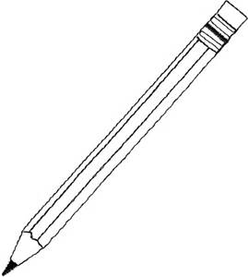

- How many sides does each shape have?

- Colour in the square above red.

- Colour the triangle above green.

- 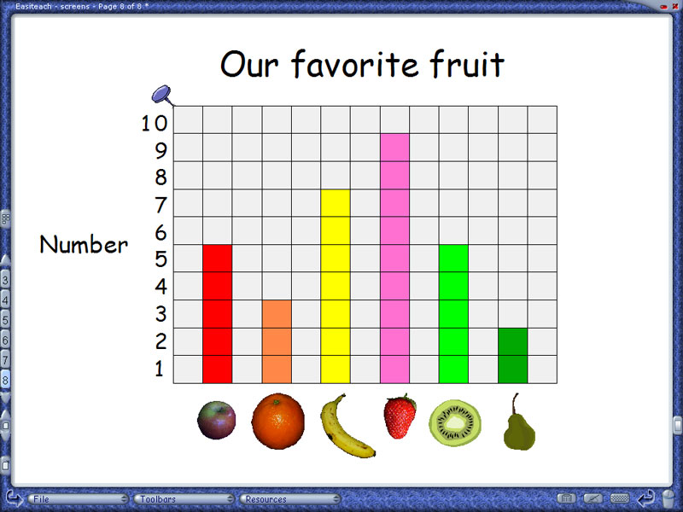

How many children like apples?
How many children like strawberries?
How many children like bananas?
- What time is it?
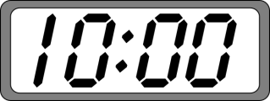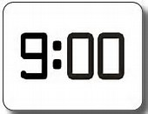

O’clock O’clock

