Revision Sheet – E**
- Write the number six.

- Write the number eight.

- Write the number that comes after 4.

- Write the number that comes before 7.

- Tick the biggest number 2 5 9

- Tick the smallest number 3 5 9

- Add together 3 and 2.

- What is 4 take away 1?

- What is 2 less than 5?

- What is 3 + 1 +2

- Colour in a quarter of this shape

- Colour in half of this shape.

- There are 4 oranges and 1 peach in the fruit bowl. How many more apples are there?

- There are 5 elephants and 4 giraffes at the zoo how many more elephants are there?

- Tick the smaller shape

- Draw a line to match the shape to its name

Circle Triangle Square Rectangle

- Complete the sequence
2 | 3 | 4 | 5

7 | 6 | 5

3 |  | 5 |  | 7

- Colour the longer pencil
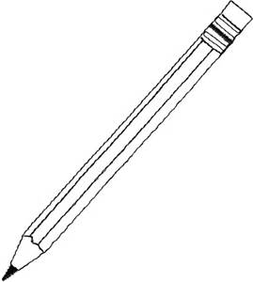

- Tick which jug would gold the most water.
