Revision Sheet 15 – Level One*

1. What 4 coins can you use to make 15p?
2. Which season comes before Winter?
3. Name this shape.
4. How many lines of symmetry does this shape have?
5. Double 12.
6. Find the sum of eight and nine.
7. **_____** + 10 = 14
8. Find the difference between 18 and 11.
9. Complete the sequence: **50, 45, 40, ___, 30, ___, 20, 15**
10. 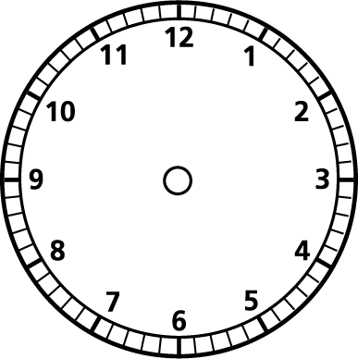Halve 6.
11. Make the clock say 12 o’clock.
12. Which is wider? A book, a car or a football pitch?
13. How many days are in May?
14. How much altogether? 10p+2p+5p+1p+1p=
15. What is 2 lots of 9?
16. Mrs Wood has 19 pencils. She loses 4. How many does she have left?
17. Find a half of 18.
18. Is **55** closer to 50 or 60?

1. Which fruit was the most popular?
2. Which fruit was the least popular?