Revision Sheet 14 – Level One*

1. What coins do you need to make 20p?
2. Which season comes after Summer?
3. Name this shape.
4. Draw lines of symmetry on this shape.
5. Double 9.
6. Find the total of six, six and six.
7. **_____** + 14 = 19
8. Add together 7 and 9.
9. Complete the sequence: **5, 10, 15, ___, 25, ___, 35, 40**
10. 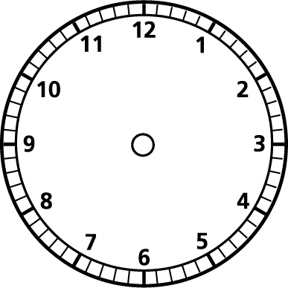Halve 20.
11. Draw the hands on the clock for 2 o’clock.
12. Which is heaviest? A dog, a mouse or a caterpillar?
13. How many days are in April?
14. Would you use *centimetres, metres or kilometres* to measure your table?
15. What is 6 lots of 10?
16. Mrs Hill needed 2 books for everyone in her class. There are 9 children.
17. Find a quarter of 12.
18. Is **15** closer to 10 or 20?
19. Which container holds the least?

Colour it.

1 litre 1000ml 500ml

1. If Mrs McDonald spends 3p, what change will she get from 20p?