Revision Sheet 13 – Level One*

1. There are 2 children at each table. There are 3 tables. How many children altogether?
2. What month comes before November?
3. Name this shape.
4. I have fifteen badges but nine are broken. How many are not broken?
5. Double 7.
6. Find the total of eight, two and nine.
7. **_____** + 6 = 20
8. If 17 – 10 = 7, what is 16 – 10?
9. Complete the sequence: **4, 8, 12, ___, 20, ___, 28, 32**
10. 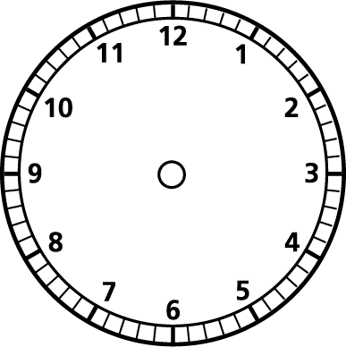Halve 16.
11. Make the clock say 11 o’clock.
12. There are 3 cows and 2 sheep in a field. Each cow has one calf and each sheep has 3 lambs. How many calves **and** lambs are there?
13. What many faces has a cube?
14. Would you use *centimetres, metres or kilometres* to measure your table?
15. What is 3 lots of 2?
16. If you get 3 sweets in a pack, how many sweets would you have in 5 packs?
17. Find a quarter of 16.
18. Is **12** closer to 10 or 20?
19. If we have tea at 5:00 and finish eating at 6:00, how long did tea last?
20. How many days are in September?