Can you make a meal plan for you and your family? What food types do you need to include lots of or some of? | Make a list of 4 acts of random kindness you can carry out for the people in your house. | Help do some gardening with an adult.
Choose a food type and create an informative poster to show it’s journey to your plate (milk, bread etc.) | Health and Wellbeing  Activity Grid  Primary 3  First Level | Create a poster about safe hand washing to display in your home’s toilet or bathroom.
Try one exercise video from each of the following sources over the course of a week…  Cosmic Kids (YouTube)  Body Coach Schools Workout (YouTube)  GoNoodle.com | 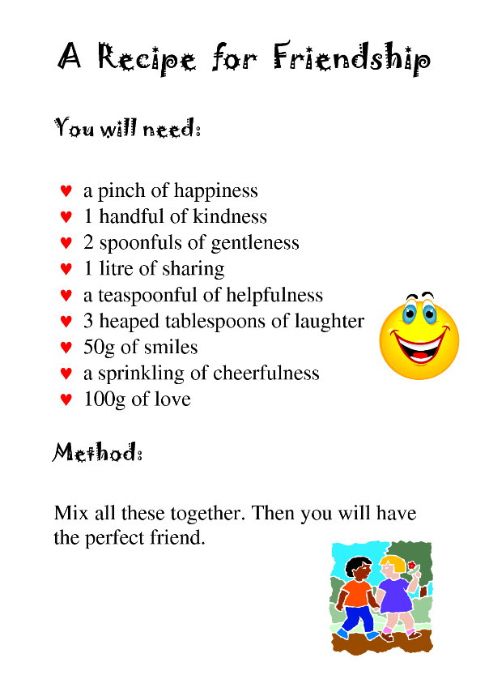  Create your own ‘Recipe for a Good Friend’ | Help prepare a meal with an adult. Can you have a go at any of the following skills? Washing, peeling, grating, cutting, juicing, etc.

