Woodburn Primary School
Writing Policy

Rationale
Writing is a major part of the curriculum and along with reading, listening and talking, makes a significant contribution to the development of children as thinkers and learners.

Writing involves a set of complex skills that will not develop without structured teaching and practice. In Woodburn Primary School we are using a variety of approaches and resources.

Throughout the school the children use a variety of texts and genre to gain more knowledge about improving their own writing.

We value writing and strive to achieve high standards from all children, within a positive writing ethos. Literacy skills empower individuals to unlock their potential as independent lifelong learners. They have a significant impact on self-esteem, motivation and aspirations for the future. Being literate equips young people to be proactive in their own learning and to articulate their thoughts. In this way they grow in an understanding of themselves as individuals and as members of society.

“Children and young people will demonstrate their progress in writing through the degree of independence they show, the organisation and quality of their ideas, their skills in spelling, punctuation and grammar, the match of their writing to audience and the effectiveness of their use of language.”
Curriculum for Excellence

To this end, Woodburn Primary School places ‘raising achievement in literacy’
at the centre of its raising standards agenda.

Aims

At Woodburn Primary School we aim to:
- have a positive writing ethos throughout the school so that pupils develop confidence and pleasure in writing
- encourage children to develop their knowledge of texts structures and language use through participating in Talk4Writing activities
- teach writing through a structured programme with agreed targets and lesson aims which are taught from Primary 1-7 give pupils a chance to voice their ideas about their progress and targets
- teach writing in a structured way to ensure progression, continuity and consistency
- link planning, teaching and assessment in every writing lesson in order to raise levels of attainment/achievement in writing throughout the school.

This policy should be read and followed in conjunction to the school’s Handwriting and Presentation policy as well as the policy on Marking and Feedback.

Time Allocation

Literacy is a key aspect of the curriculum and opportunities to practice writing skills should be available throughout all subjects and areas taught across within the context of IDL. Therefore time allocation will be flexible as in line with Curriculum for Excellence.

Learning and Teaching

Learning and Teaching is based on Curriculum for Excellence Experiences and Outcomes and a wide range of materials supports it.

• Resources
Resources in the school range from those purchased from educational suppliers to writing stimuli gathered within school by teaching staff.
These will include: textbooks, pictures, videos, planning sheets, novels, non-fiction texts, text in a variety of genres, CDs and big books.
(A list of resources at Woodburn is included as appendix 1)

• Frequency and Range of writing
Children should be exposed to a balance of Personal, Imaginative and Functional writing throughout the year. Coverage of which genre that have been taught and the context of the writing will be tracked and passed on during transition to ensure balance.
(The copy of the tracking sheet is included as appendix 2)

• Forward Planning
Writing is planned using the Midlothian Writing Rubrics as they contain the genre specific features and show progression across genre from Early to Third levels.
Progression Pathways for Writing are also used to ensure progression through the level towards the benchmarks.

• Classroom Organisation and Methodology
All classes will have a display for writing. It will include examples of VCOP from the Big Writing approach that are used as a general resource to improve the style and structure of sentences. This will be applicable to stage of the learners.

Various resources will be available to pupils to aid with the spelling aspect of writing (word mats, dictionaries, electronic spell checkers etc.)

The Talk for Writing approach is being implemented in school. This approach means that children become immersed in stories and non-fiction texts and can re-tell them verbally before learning the structure of the text and the features it has. Pupils will then begin to use story/ text mapping to plan their own versions of the text they have been working on, eventually leading to independently creating their own text.

Pupils will have opportunities throughout the year to edit and redraft their own work.

All classrooms will display examples of good work (WAGOLLs). Staff will ensure that all
pupils are given recognition for their writing achievement at some point during the session.

Staff will use a range of stimuli to encourage the children in their class to write. These stimuli will be under the headings of; Big Books, visual stimuli (such as art work), modelled stories, cross-curricular lessons and trips, stories from authors and other children, aural stimuli (such as music extracts and drama activities).

Grammar, spelling and handwriting are important technical skills, which are developed through specifically taught lessons. During writing lessons the children will be expected to demonstrate their ability and understanding of these skills.

Progression in Grammar is ensured through the use of the Talk4Writing progression. Spelling coverage is dependent on the stage of the child. Words and foci will follow either the Read Write Inc/ Fresh Start programme or the National Strategy for Spelling (DfES).
Handwriting is taught using the MSL Cursive Rescue Scheme.

Assessment

Assessment is an integral part of the learning and teaching process. A balance between formative and summative assessment will be used to:
- provide pupils with clear and regular feedback
- assist learners and teachers to plan next steps
- evaluate the effectiveness of teaching

Formative and Summative Assessment
Extended pieces of work produced at the end of a block of teaching should be assessed using the Midlothian Writing Rubric specific for the genre it is. (see appendix 3).

It is suggested that at least 4 of the genres covered throughout the year should be assessed using the Writing Rubrics therefore giving an idea of attainment across a variety of genre.

Regular, meaningful, formative feedback should be given to pupils in terms of pupil successes and clear targets for further improvement. For further guidance refer to the policy on feedback and marking.

Monitoring and Tracking
Monitoring will be carried out by the SLT and school staff who will sample pupils work from each class and discuss children’s progress with teaching staff.

All staff are encouraged to engage in professional dialogue to ensure that there is a shared understanding of standards. There will be opportunities for staff to take part in cross stage moderation of pupils’ work throughout the year at school and authority level. These opportunities to share the standard will lead to increased teacher confidence and better progression for pupils from one level to the next.

Roles and Responsibilities

The role of the Management Team will be to:
- create an ethos of achievement in literacy
- provide a clear policy for skills development in writing
- ensure rigorous assessment and monitoring takes place
- promote literacy across the curriculum
- ensure staff access appropriate training opportunities

The role of teaching staff will be to:
- take account of pupils’ prior learning when planning next steps
- employ a variety of teaching strategies to take account of different
- learning styles
- create a literate environment
- share criteria and aims of lessons with children
- use effective questioning techniques
- have high but realistic expectations of children
- be an effective role model in promoting literacy
- use a variety of resources, including ICT
- set the pace of learning to ensure challenge
- encourage independent learning

Parents are asked to support the work of the school through encouraging children in home learning tasks. (For example, looking for examples of VCOP, listening to pupils retell their stories and texts, talk with pupils to assist the content ).

Regularly reading with children is an important way to demonstrate the significance of literacy.

Pupils are expected to participate fully in all classroom and homework activities. Children will be set and have the opportunity to should set themselves targets and have high expectations of the work they can produce. Pupils have a responsibility to read the formative assessment comments and verbal feedback given about their work to improve their future writing.

Pupils with Additional Support Needs will be supported by the procedures outlined in ABLE plans/ IEPs and the support and guidance from relevant outside agencies. These pupils may be supported by Learning Assistants or given further explanation and/or be supported individually by the class teacher.

Appendix 1 List of Resources

Talk 4 Writing | 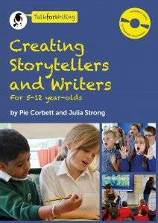
 | 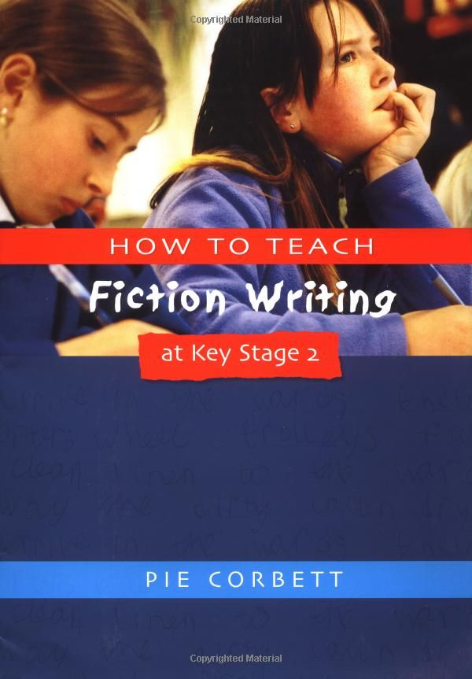
 | 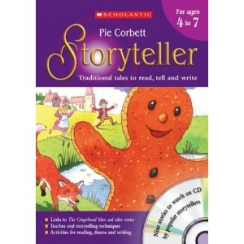
 | 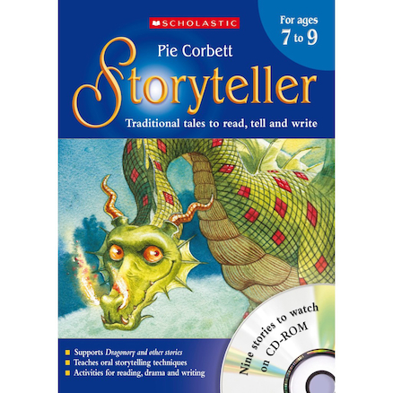
 | 
 | 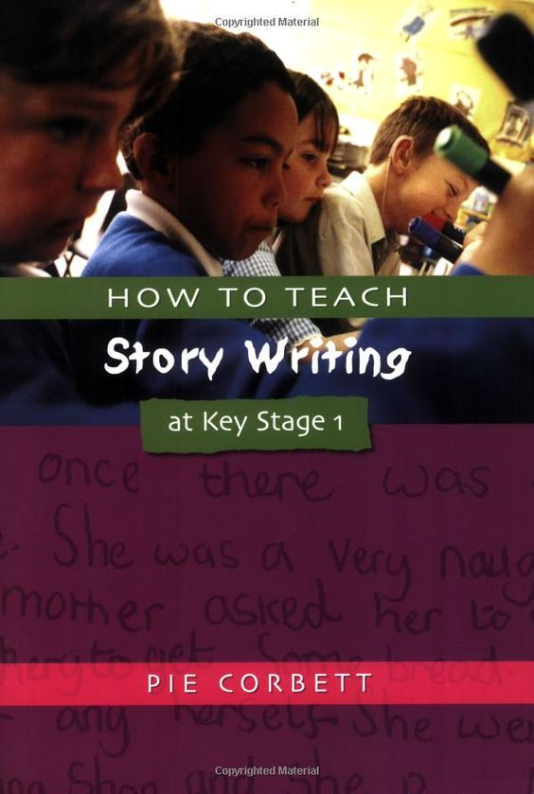
Grammar progression | 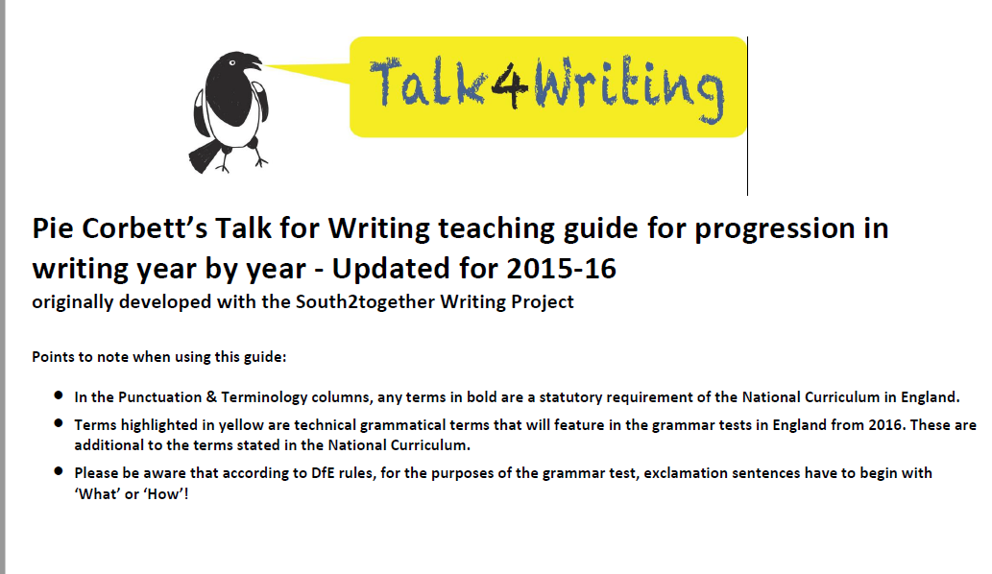
Spelling | 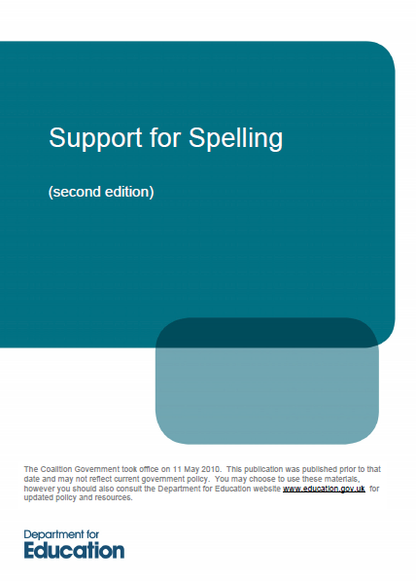
 | 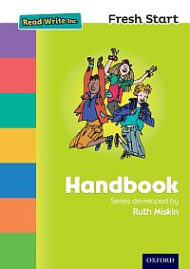
Handwriting | 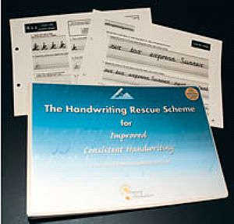

Appendix 2 Genre and coverage tracking sheet
Appendix 3 Midlothian Writing Rubrics



