COMMUNITY BASED ADULT LEARNING
DANDERHALL

Family/Local History

Thursdays, 10.00-12.00
24 October – 12 December 2019
Danderhall Library

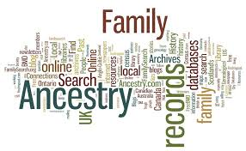
This course is for anyone interested in researching their own ancestry. Learn how to research and interpret records to create your family tree. Discover a wide range of local and online sources of historical information which will help you find out who your ancestors were and how they lived. 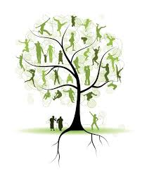
For more information about the courses or to find out how to book a place please go to: www.midlothian.gov.uk

Or contact us on:
Tel: 0131 271 3481
Email: LLEadultsfamilies@midlothian.gov.uk
Facebook: facebook.com/LLEMidlothian
Twitter: @LLEadult_family

