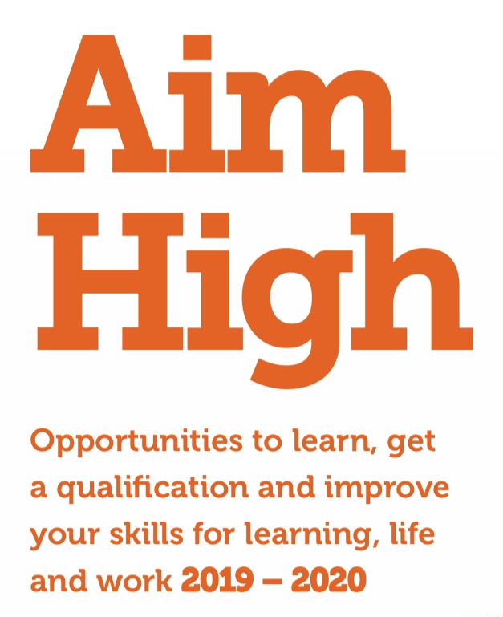
DIGITAL SKILLS

These courses are designed so that you can work at your own pace and focus on the skills you want to develop. These may include using a range of computer programmes, email, online safety, social media, online banking, and online shopping. We can help to identify programmes and apps that are useful.

Wednesdays starting 25 September 2019
@ Dalkeith Library, White Hart Street, Dalkeith
11.15am-12.45pm

Thursdays starting 26 September 2019
@ Croft Street, Dalkeith
9.30am-11.30am
For more information about the courses or to find out how to book a place please go to: www.midlothian.gov.uk

Or contact us on:
Tel: 0131 271 3481
Email: LLEadultsfamilies@midlothian.gov.uk
Facebook: facebook.com/LLEMidlothian
Twitter: @LLEadult_family

For more information or to book a place please go to: LLEMidlothian.eventbrite.co.uk

Or contact us on:
Tel: 0131 271 3481
email: LLEadultsfamilies@midlothian.gov.uk Facebook: facebook.com/LLEMidlothian
Twitter: @LLEadult_family

