Science in School:
What’s it all about?

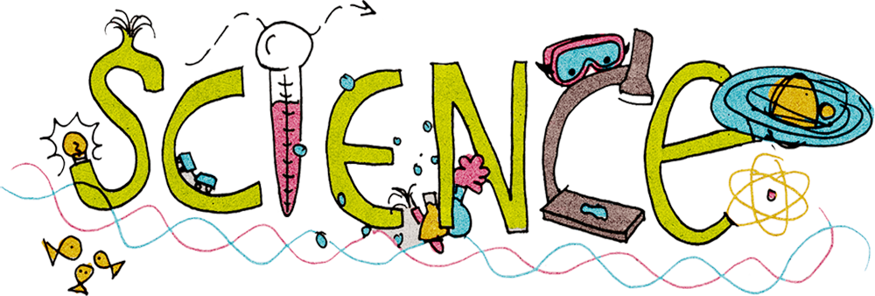

Why learn science?
Scotland’s history is rich in important scientific discoveries and in Midlothian this field is of particular relevance. We want our pupils to leave school with the skills, understanding of the world and care for our environment that learning in the sciences nurtures.
Through learning in the sciences, children and young people develop their interest in, and understanding of, the living, material and physical world. They engage in a wide range of collaborative investigative tasks, which allows them to develop important skills to become creative, inventive and enterprising adults in a world where the skills and knowledge of the sciences are needed across all sectors of the economy.
Education Scotland

How do we teach science?
Learning in science is divided into the following five subject areas:

Planet Earth 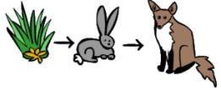
This includes learning about how living things are connected to each other, energy sources and sustainability, earth’s water, and space.
Forces, electricity and waves 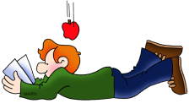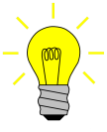
This includes learning about electricity, light, sound and gravity.
Biological systems 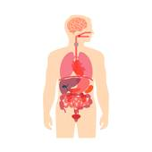
This includes learning about body systems, cells and genes.

Materials 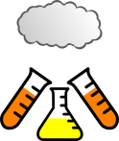
This includes learning about liquids, gases and solids, chemical changes and
what properties different substances have.

Topical science
Learning about how science benefits our society and considering different scientific developments.

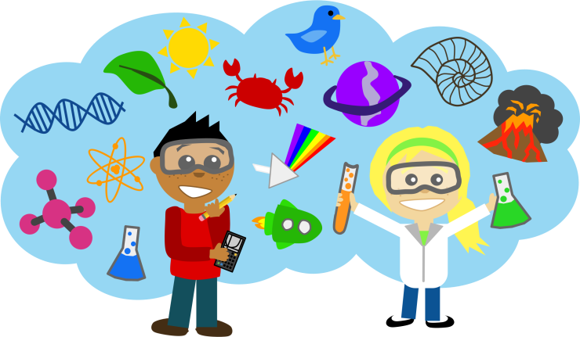
How you can support Science learning at Home!

Planet Earth
Biodiversity and Interdependence
- Get your child involved in gardening at home.
- Grow fruit and vegetables.
- Talk about the different parts of flowers and plants.
- Read books about living and non-living things.
- Watch nature documentaries.
- Visit the local garden centre, park or Botanic Gardens.
- Talk about the positive effects plants and trees have on us- giving us air to breathe!
Processes of the planet
- Make ice cubes and melt them again; talk about what is happening.
- Read stories about the weather and water (Noah's Ark) and share experiences.
- Float and sink objects in the bath or sink.
- Read Mr Archimedes' Bath and talk about why the water rises in their bath.
- Talk about the clothes they are wearing on particular days and discuss why they are wearing them
- Use thermometers to look at temperatures inside and outside your home.
- Discuss topical stories in the news about climate change and its effect on the rest of the world.

Forces, electricity and waves
Vibrations and waves
- Make instruments from junk (cardboard, plastic cups, rice, peas). Talk about the volume of each instrument.
- Talk about the sounds of the items you have in your kitchen, bathroom etc.
- Walk around your local area and listen for as many sounds as possible.
- What material will make the loudest instrument or the quietest?
- Discuss how different species of animals communicate. Is there a common feature? Is it all different? How do you know they are communicating?
- Make paper aeroplanes and test them. What makes them work well?
- Talk about why things fall down when you let go of them.

Materials
Properties and uses of substances
- Read The Three Little Pigs and share the reasons for the success of each materials.
- Make junk models with different materials and for different purposes (bridge, house for action figure/doll) and test it to see if it works.
- Make parachutes with different materials, test them to see which is most successful.
- Play the ‘mineral, vegetable, animal’ guessing game. Your child will have to think about what the object is made of and what category it fits in.
- Use different items around the house to test how long each might take to dissolve ice cubes and discuss why this might be useful in different seasons.
- Mix together lentils, salt and sand in a tub and see if you can work out how to separate the three materials again.

Biological systems
Body system and cells
- Talk about the correct names of body parts.
- Talk about the senses, what can you see, hear, feel, taste and touch around you.
- Play with a toy doctor's set and explore different parts of the body. Talk about what's on the inside too.
- Talk about what job the skeleton does.
- Talk about good hygiene and how germs are spread.
- Relate how your organs are important for good health and how to look after them.
- Talk about the importance of vaccinations and how they provide protection.

Topical science
- Watch the local and/or national news and talk to your child about the science stories.
- Watch Newsround and explore the Newsround website for topical science stories.
- Discuss stories you read in the newspaper or magazine.
- Research famous scientists (for example Thomas Addison, Alexander Graham Bell, Alexander Fleming) using books or the internet and discuss how they have contributed to science development.

