

**Woodburn Primary School**

**Standards and Quality Report 2017-2018 and Overview of Priorities for 2018-2019**

Welcome to our Standards and Quality Report for 2017-2018 and overview of our priorities for the 2018-2019 school session. The full document is available on our school website.

**Through the school session 2017-2018 we focussed on the following priorities:**

1. To raise attainment in Numeracy and Maths.
2. To raise attainment in Literacy and English.
3. To develop learning and teaching practices.
4. To build positive relationships with parents/carers through increasing engagement.
5. To support learners with Additional Support Needs effectively.

**Highlights from Session 2017-2018**

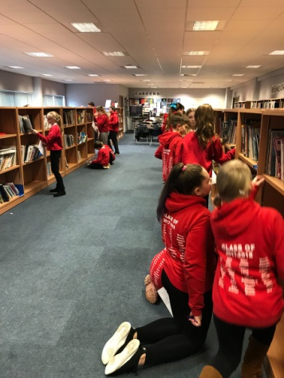We continue to make effective use of research from Scotland and beyond to inform learning and development. A good example are our links with James Nottingham (Challenging Learning) and OSIRIS Educational. We have continued this session to host Challenging Learning study tours. The school hosted visitors from Denmark, Sweden and Norway who were keen to understand how children at Woodburn Primary School learn. House Captains and Vice House Captains are school tour guides for any visitors that we welcome to Woodburn and there have been many positive comments regarding how well they can share their knowledge related to learning and teaching and how enthusiastic and proud they are of their school.

Staff work effectively as a team. There is a strong ethos of sharing practice and of peer support and challenge. Staff plan together and participate in improvement activities with Dalkeith Learning Community colleagues. In the 2017-2018 session this has focused on raising attainment in reading and included practitioner enquiry and moderation activities. This has supported collaboration, staff understanding of Impact Cycles and through looking more closely at the benchmarks, understanding of progress and achievement of a level. There have been opportunities for children in Primary 7 to visit Dalkeith High School and High School teachers from a variety of subjects have visited Woodburn to teach lessons. This has supported learners through transition.

Members of staff have taken on leadership responsibilities across school, these include:

* Teaching staff who have completed Impact Coaching Training and will lead work focussing on ‘Feedback’ next session.
* Teaching staff who have lead curricular areas.
* Learning Assistants who have trained in Read Write Inc. are competently leading groups,
* Teaching staff who have mentored students.
* 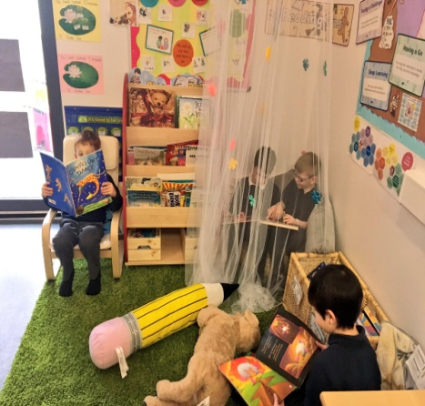Senior Childcare and Development Workers and Childcare and Development Workers who have taken responsibility for leading areas such as PEEP, Messy Play and The Big Bedtime Read.

A great deal of work has been put into developing our school library. Committed parents/carers continue to support each week in our Library. Reading environments were extended to other areas of the school where pupil voice shaped a range of different ‘spaces’ to relax and read. This was part of the Dalkeith Learning Community Practitioner Enquiry.

Two members of staff are in the process of undertaking an Action Research Project linked to the work of Shirley Clarke. They will continue to develop this through the 2018-2019 school session.

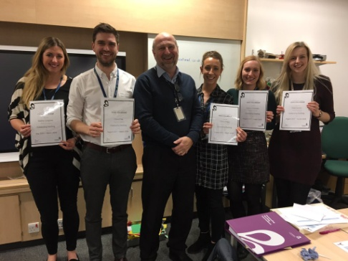Five members of teaching staff completed the Outstanding Teacher Intervention Programme. This supports teachers through three modules (Engagement, Challenge, Feedback). Staff attending were able to state positive impacts on their practice and on learners’ experience.

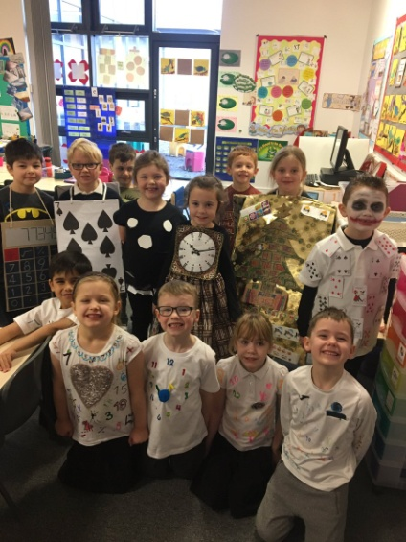Staff have continued to focus on our Woodburn Learning Skills. The language around each learning skill/character has been exemplified and shared with parents/carers. OSIRIS supported a Visible Learning Scoping exercise which highlighted our strengths related to learning dispositions and growth mind set. The language of learning in Woodburn was evidenced to be particularly strong. Focus groups were able to articulate their use of different learning skills. We shared how we have promoted a Language of Learning Culture at the Launch of Midlothian’s Centre for Research and Innovation in Learning.

Read, Write Count was launched successfully from Primary 4-7 with a Reading and Numeracy focus week which included staff and children coming dressed up as a number, there were very creative ideas. Parents/carers were initially invited into school to look at the resources with their children before they were sent home for families to engage with together.

We held a whole school Science Week where classes engaged in learning activities related to STEM subjects, this was shared successfully with parents/carers through a Shared Learning event.

A parent/carer who works at BT trained staff in a programme created to support Technology Experiences and Outcomes related to Computing Science. The programme and resources have been utilised by staff.

Primary 7 pupils participated in the ‘Grow a Pound’ Enterprise Project where with an initial loan of £1 they had to plan one or a few projects to grow profit from the money loaned. This supported the development of enterprising knowledge and skills.

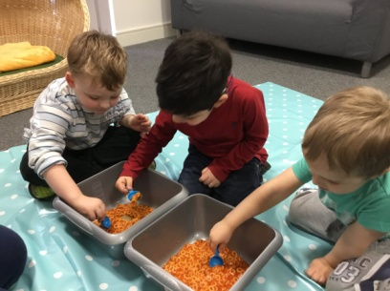Procedures for highlighting and tracking children’s wellbeing have supported outcomes for children by implementing effective interventions. This has included work undertaken along with the Family Learning Centre and Early Years ASN Team and two new members of staff appointed through Pupil Equity Funding (PEF). The Early Years Homelink Worker and a Youth Worker roles compliment our other interventions. These include:

* Supports to increase attendance and reduce lates.
* PEEP
* Language is Fun Together (LIFT)
* Messy Play
* Participation fund for camp and after school activities
* Nurturing approaches/environments
* Play Therapy (1-1, group and drop-in)

Staff and children have developed a good knowledge of learners’ rights (UNCRC) and we were successful in being awarded Rights Respecting School Silver Award.

Lead by two members of teaching staff, our choir became a ‘Glee’ Choir who performed in a National competition at the Brunton Hall, Musselburgh. They performed with confidence in front of an audience including their families and school staff. Further performances of the Glee choir followed including at the Parent Partnership Summer Fair.

In June 2018 we were awarded a Silver Sports Award. This highlights our commitment to ensuring that within school and as extra-curricular activities we are providing opportunities for our children to participate in sport.

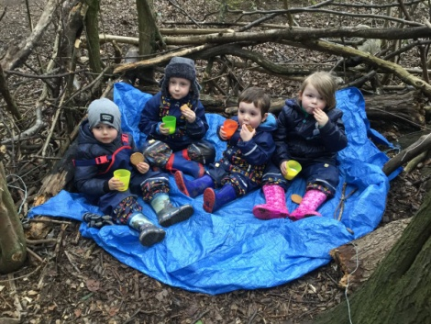Primary 6 and 7 took part in a competition with Sustrans to design the Milestones marking part of the route of the National Cycle Network. From all the schools who took part, 8 of the shortlisted entries were from Woodburn Primary. In addition to this, the 2 competition winners were also from Woodburn Primary. The shortlisted and winning designs were displayed in Dalkeith Arts Centre and the children were invited to see their designs being painted on to the milestone markers.

Primary 5 enjoyed a two night residential at Dalguise and Primary 7 pupils joined other schools within the Dalkeith Learning Community to attend Whitaugh Camp for three nights. The Nursery children have enjoyed a ‘Wednesday Wellie Walk’ and a group of teaching staff and Learning Assistants completed two sessions of Forest Schools Training with Edinburgh and Lothians Greenspace Trust and the Forestry Commission. They also lead Forest Schools activities with classes as part of the project.

Staff have undertaken a variety of training opportunities to further develop their practice to support our children including:

* Team Teach Training
* Clicker
* Nurture ABC (Lego as a therapeutic play intervention)
* Call Scotland Training – use of the technologies to support children with Additional Support Needs

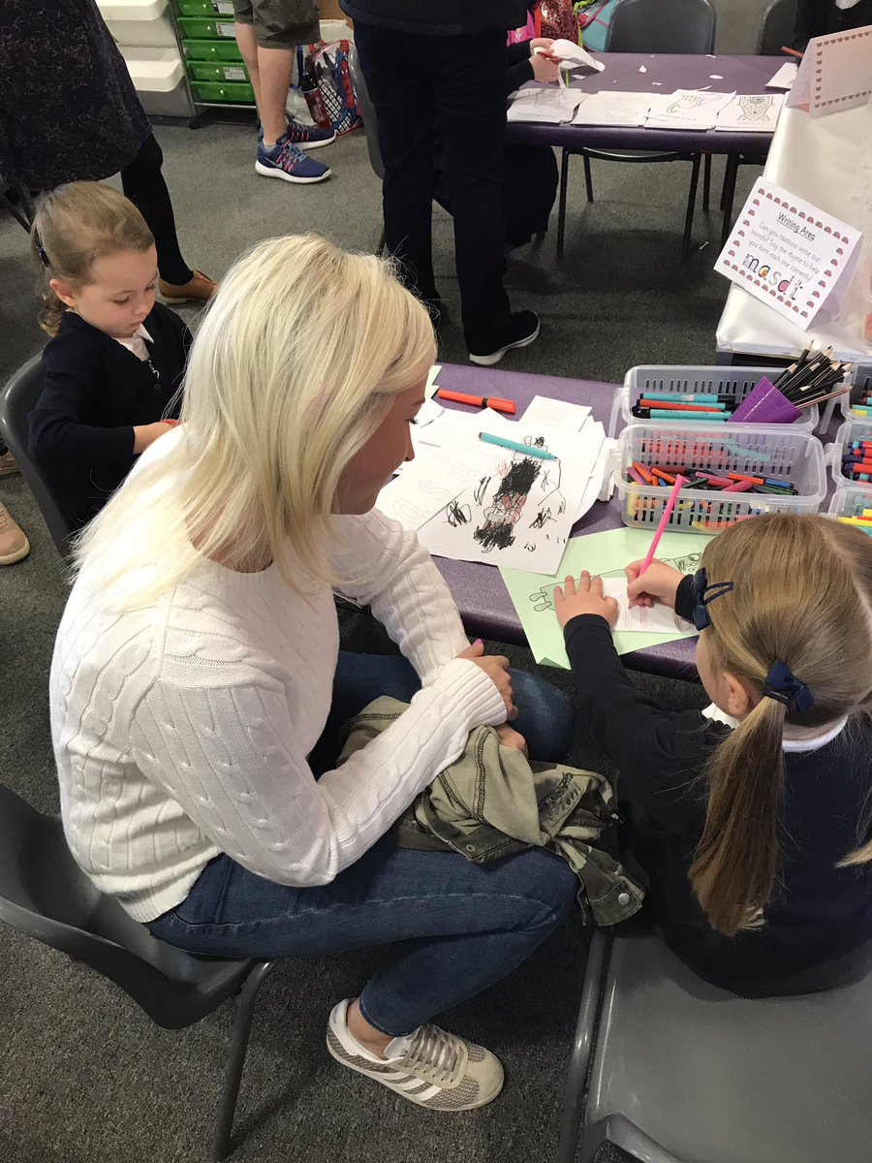There have been opportunities for parents/carers to be involved in school events. They have been invited for curriculum evenings in Primary 1 and information afternoons have been held to inform parents about how the school and parents can support their child’s reading/phonics using the Read, Write Inc approach. There have been several opportunities through the year for parents/carers to join their child in learning experiences in Nursery and school and key events such as Nativity, Scots Night, and Harvest Assemblies.

Parents have been consulted regarding a number of school decisions. This included focus groups of children and families who worked through exercises focusing on the cost of the school day to agree how to spend an additional £11 000 granted to the Parent Partnership.

The Parent Partnership continues to support the work of the school, increasingly at a strategic level and also through planning social events for children and families. These included Monster Mash, Primary1/2 ‘Movie Night’ and a Summer Fair. This session they have used funds raised to help the school subsidise the cost of buses to take children to the Pantomime (December 2018) and to purchase iPads.

Thanks to two of our Primary 4 parents, our playground planters have been repaired and painted. Our lunchtime gardeners have been busy weeding them and over the Summer they will be planted.

Links have been made with local MSPs to support the Learning and Teaching of the Scottish Democracy topic taught in the upper school. The Primary 6 children attended a story telling session at St Marys Church in Dalkeith to commemorate 100 years since women were given the vote and to reflect on the suffragette movement.

We have continued to link with Queen Margaret University and the Children’s University. We had 9 children gain accreditation with the Children’s University and graduate this session, this brings the total to 25.

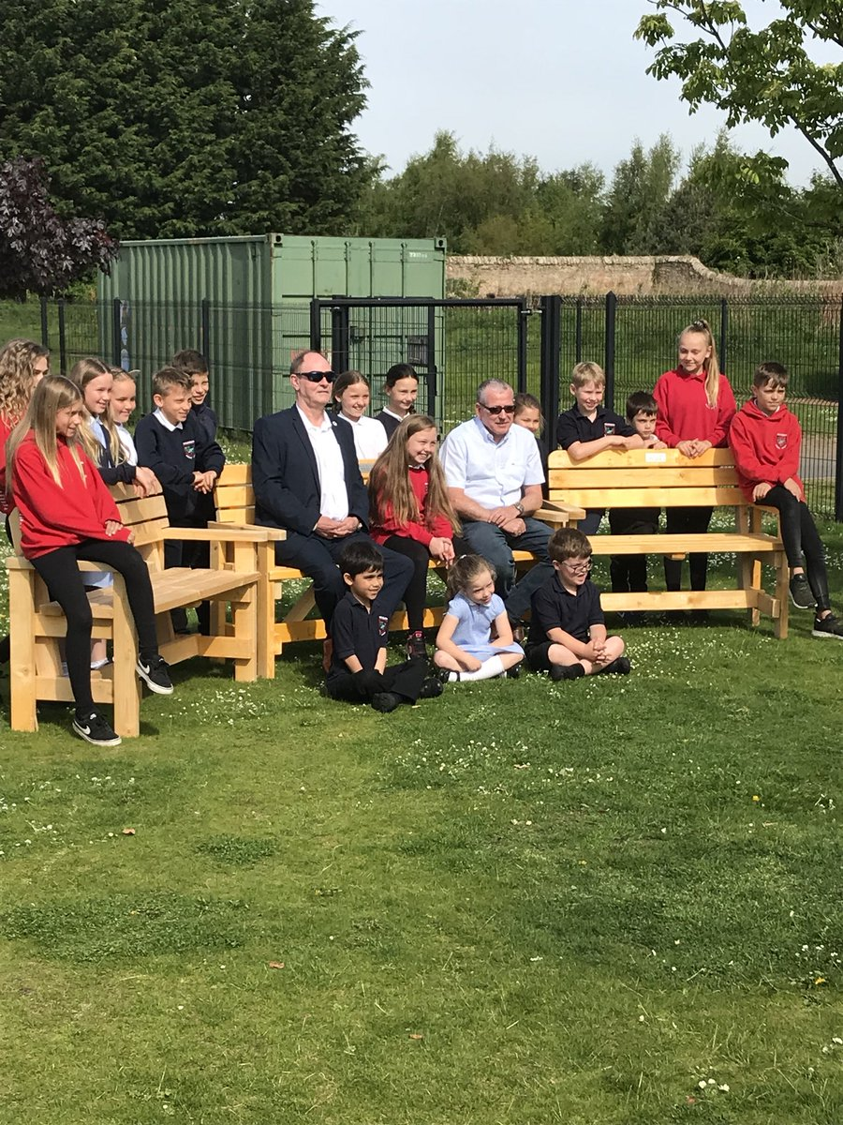We have continued our link with Storehouse who support a weekly Home Learning Club for some of our children who find completing these tasks at home difficult. We have 30 regular attendees.

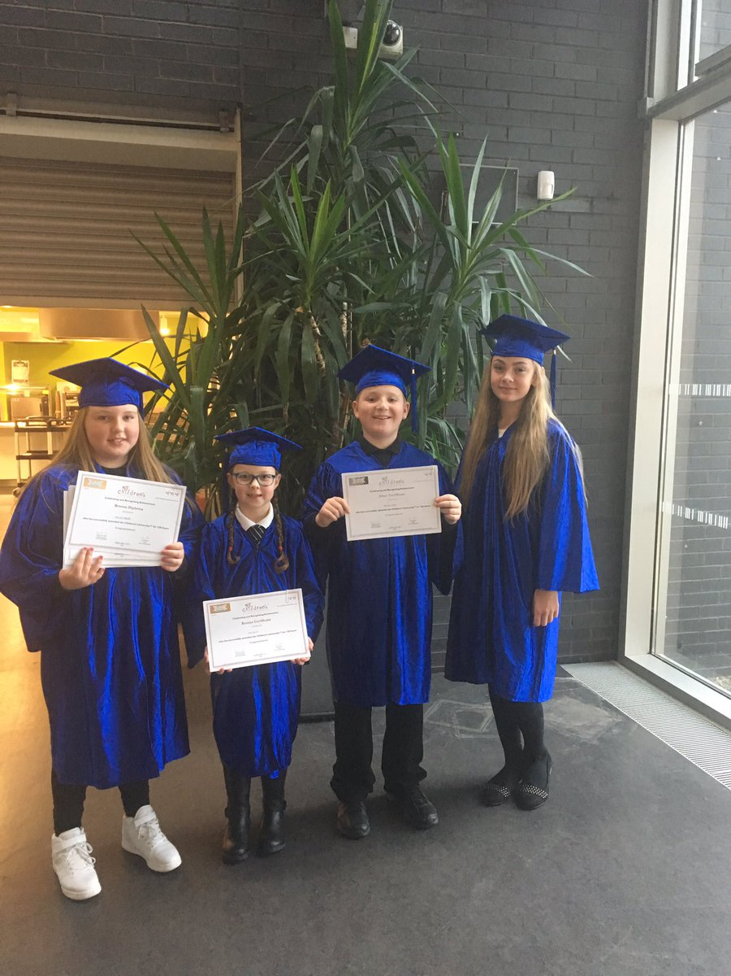We have continued to celebrate children’s Out of School Achievements. In addition to children sharing achievements in areas such as sport, we have had lovely examples of good citizenship which include:

* A Primary 6 child who fund raised and bought foods to deliver to those in need.
* Two children who had their hair cut and donated it to the Princess Cancer Trust.
* A Primary 7 pupil who wanted the children at our school to have somewhere to go if they needed a friend to play with and speak to fundraised over £400 for her friendship benches. Scottish War Blinded veterans built the benches and unveiled them.
* Children from our school planned and organised a litter pick in our local woodland area.

**Curriculum for Excellence Attainment**

Literacy and English - There has been an increase in the percentage of pupils achieving the CfE expected levels with the exception of a slight decrease in Reading at Primary 4.

Numeracy and Maths - There has been an increase in the percentage of pupils achieving the CfE expected level at Early and First Level but a decrease at Primary 4.

|  |  |  |  |  |
| --- | --- | --- | --- | --- |
|  | Listening & Talking | Reading | Writing | Mathematics |
| % pupils at P1 achieving Early Level or higher June 2017 | 78.3 | 62.1 | 54 | 47.22 |
| % pupils at P1 achieving Early Level or higherJune 2018 | 91.4 | 72.8 | 64.2 | 71.6 |
| % pupils at P4 achieving First Level or higher June 2017 | 67.2 | 78.6 | 62.2 | 77 |
| % pupils at P4 achieving First Level or higher June 2018 | 80.6 | 73.1 | 67.2 | 73.1 |
| % pupils at P7 achieving Second Level or higher June 2017 | 55.7 | 63.4 | 50 | 21.1 |
| % pupils at P7 achieving Second Level or higherJune 2018 | 74.1 | 70.7 | 67.2 | 60.3 |

**Priorities for 2018-2019**

1. To raise attainment in Literacy and Numeracy.
2. To support children and families to increase pupils attendance, engagement and participation.

To support learners through interventions which support their learning and wellbeing.

1. To work towards becoming a ‘nurturing school’.
2. To improve Broad General Education curriculum long term / medium term planning frameworks.

To develop learning and teaching approaches that impact on attainment.