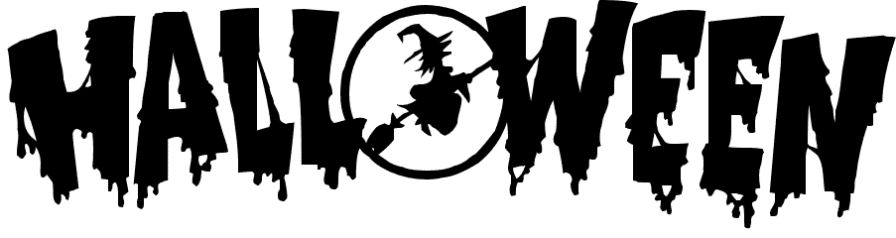
Woodburn Parent Council ‘Monster Mash’ Family Party
Friday 30th October: 6.30-8.30PM
Tickets for this event are on sale from Tuesday 6th October.
9am at the back of the school (dinner hall doors).
£2.50 per person.
Thereafter in the playground from Debbie Lawson P2 mum – the office will not sell tickets
Price includes: Disco, Party Games, Bingo and Dooking.
Fancy dress is optional.
Primary 4 - 7 can attend without an adult but MUST be collected by a parent/guardian (age 18+) at 8.30pm. (all children under P4 must be accompanied by an adult)
Due to high demand we limit the ticket sales to one adult per group, allowing more school children to attend.

Woodburn Parent Council ‘Monster Mash’ Family Party
Friday 30th October - 6.30-8.30PM
Tickets for this event are on sale from Tuesday 6th October.
9am at the back of the school (dinner hall doors).
£2.50 per person.
Thereafter in the playground from Debbie Lawson P2 mum – the office will not sell tickets
Price includes: Disco, Party Games, Bingo and Dooking.
Fancy dress is optional.
Primary 4 - 7 can attend without an adult but MUST be collected by a parent/guardian (age 18+) at 8.30pm. (all children under P4 must be accompanied by an adult)
Due to high demand we limit the ticket sales to one adult per group, allowing more school children to attend.

